7.6 BPMN Extensibility
BPMN 2.0 introduces an extensibility mechanism that allows extending standard BPMN elements with additional attributes. It can be used by modelers and modeling tools to add non-standard elements or Artifacts to satisfy a specific need, such as the unique requirements of a vertical domain, and still have valid BPMN Core. Extension attributes MUST NOT contradict the semantics of any BPMN element. In addition, while extensible, BPMN Diagrams should still have the basic look-and-feel so that a Diagram by any modeler should be easily understood by any viewer of the Diagram. Thus the footprint of the basic flow elements (Events, Activities, and Gateways) MUST NOT be altered. The specification differentiates between mandatory and optional extensions (Section 8.2.3 explains the syntax used to declare extensions). If a mandatory extension is used, a compliant implementation MUST understand the extension. If an optional extension is used, a compliant implementation MAY ignore the extension.
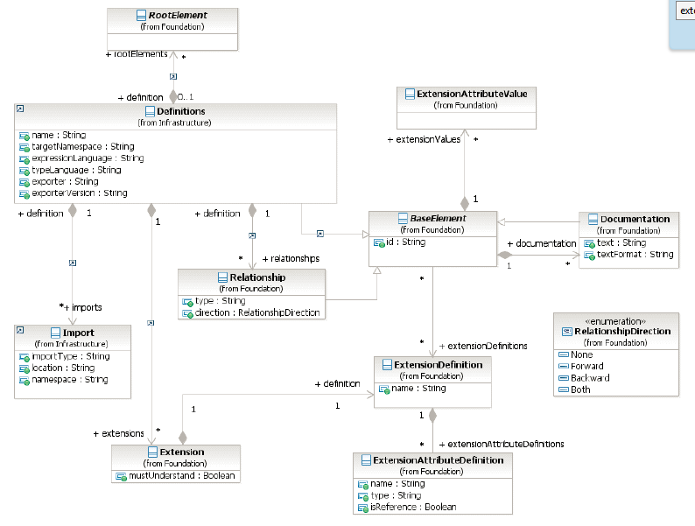

8.2.3 Extensibility The BPMN metamodel is aimed to be extensible. This allows BPMN adopters to extend the specified metamodel in a way that allows them to be still BPMN-compliant. It provides a set of extension elements, which allows BPMN adopters to attach additional attributes and elements to standard and existing BPMN elements. This approach results in more interchangeable models, because the standard elements are still intact and can still be understood by other BPMN adopters. It’s only the additional attributes and elements that MAY be lost during interchange. Figure 8.6 - Extension class diagram A BPMN Extension basically consists of four different elements: 1. Extension
A BPMN Extension basically consists of four different elements: 1. Extension 2. ExtensionDefinition 3. ExtensionAttributeDefinition 4. ExtensionAttributeValue
